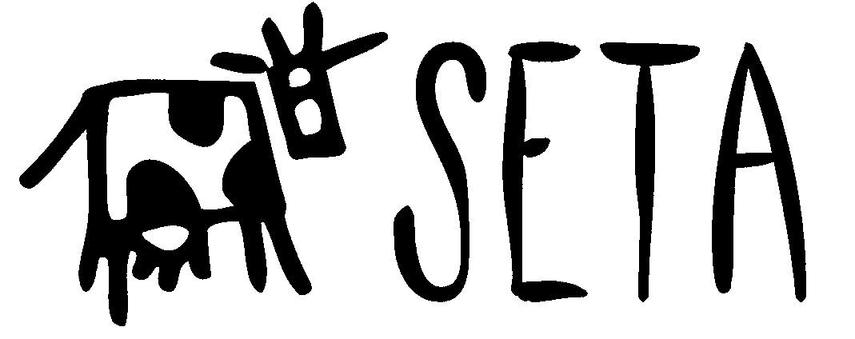
newsletter #1
20 August 1997

informing the San Marcos
animal rights community

S t u d e n t s f o r t h e E t h i c a l T r e a t m e n t o f A n i m a l s

SETA update
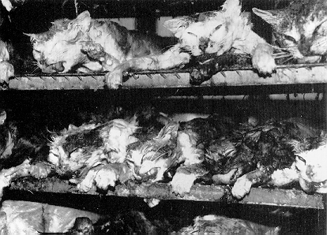
embalmed cats bound for dissection

Soon the regular semester will be starting again, and many of us will be returning to Southwest for yet another semester of college. This semester SETA will once again be active and in need of all the support it can get to try to make a difference for the animals who, like children, have no means with which to defend themselves against a society that relegates them to the status of objects out of calous selfishness. We do have an opportunity to begin to change that, but only if we try.

As many of you already know, SETA does not require that any of its members follow any particular ideology. Rather, the organization is a means for its members to work on the animal rights issues that they care about. If you are concerned about the routine death of dogs and cats in animal shelters due to overpopulation, uneccesary dissection, the animal testing performed on laboratory rabbits, cats, dogs, and rats every day, ecofeminism, vegetarianism, or any other issue you are very welcome in our group. None of our activities are in any way mandatory. We have a very open organizational structure- anyone can suggest and carry out any activity they like. Just come to a meeting and suggest it. If your idea is a good one, chances are other people will be intersted in helping you.
There is no fundamental difference between man and the higher animals in their mental faculties... The lower animals, like man, manifestly feel pleasure and pain, happiness, and misery.
Charles Darwin

Our weekly organizing meetings will be at the same time and place as last semester- Tuesdays at 8:30 in the Pedernales room in the LBJ student center. The first will be on the 9th of September. If you need directions feel free to call Patrick at 512.353.2451. Please do not feel that you have to come to all or even many of the meetings to be a member of the group. Feel free to drop in whenever you are not busy.

What we actually do this semester will be decided in the meetings of course, but some possibilities include tabling on campus and selling tasty vegan snacks as a fund raiser, showing PETA and other animal rights videos on campus television, agressively posting fliers for the animal shelter and other animal rights issues, printing SETA and/or animal rights t-shirts, participating in protests and animal rights events in conjunction with Austin and San Antonio groups, pot lucks open to the public, publishing a vegetarian/vegan restraunt report, serving as a resource for campus and local journalists for the animal rights perspective, and maybe even finding time to write a few old fashioned letters of protest.

disease research subjects
Many of their counterparts are not so lucky as to
have another creature to cling to for comfort.

Also, I have been conducting a search for guest speakers, and I have leads for three interesting people at this time. One which is almost assured at this point is a professor from UT San Antonio who has written extensively on animal rights issues. He has a forthcoming book due out from Oxford press dealing with the rights of animals under ethical theories, and how mainstream theories fail to adequately justify the exclusion of animals from ethical consideration. Another potential speaker is the founder of O.O.A.S.I.S. a program promoting sustainable community agriculture. A third is an ex-rancher turned vegan who routinely talks to student groups around the country. All three charge nothing and will speak for the cost of getting them here and putting them up in a motel room. I will have more on this at our first meeting.

For information, questions, or suggestions contact me (Patrick) in San Marcos at 512.353.2451, or at ph38013@swt.edu.
news

Vegetarians Tell Dave To Stuff It Better: FTC/FDA Complaints Filed
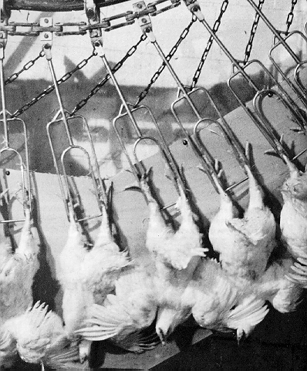
in a chicken slaughterhouse

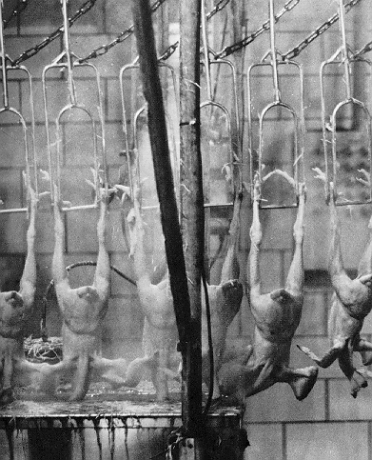
after feather removal

In this photo you can clearly see where each
chicken cut comes from.

WASHINGTON--(BUSINESS WIRE FEATURES) -- There's talk on the Internet about a Wendy's boycott, a class-action lawsuit, and federal regulatory agency complaints. This comes hot on the heels of the widely-publicized McLibel verdict on June 19. Hey, what's the big huff?

Vegetarians are thanking Dave Thomas for trying to stuff his Veggie Pita right for them. However, they are asking if it might just be possible to make it "all vegetable" as promoted.

Many vegetarians ate the pita thinking they were getting something "vegetarian" and "all vegetable" as advertised in Wendy's Nutrition Guide. The potential for litigation looms. An example of a precedent is a Boulder, Co. police officer who successfully sued over meat-laden tomato sauce misrepresented as vegetarian.

"At first, we caught Dave with his pants down. Then, six weeks later, he was in the buff," exclaims Lige Weill, president of the Vegetarian Awareness Network, a national public-interest organization.

On May 9, Weill contacted the Consumer Relations Department of Wendy's International, Inc. in Dublin, Ohio after being alerted to pita problems by Utica, N.Y. consumer activist Pat Fish. Fish said Wendy's Fresh Stuffed Garden Veggie Pita contained gelatin in the sauce.

Gelatin comes from the collagen-bearing tissues of any animal slaughtered for food, and it is certainly not vegetarian.

On June 23, Linda Theado, an employee in Wendy's Research and
Development Department, told Weill she had been working since February to remove the gelatin. The pita was rolled out in April, according to Theado.

"Wendy's knew about the gelatin before the pita was even in its restaurants if what Theado said is accurate. It became apparent Wendy's was not going to make the public aware of the pita problems without pressure," says Weill.

The Vegetarian Awareness Network had heard enough. On June 26, it filed formal complaints with the Federal Trade Commission and the Food and Drug Administration, charging that the pita was not "vegetarian" or "all vegetable" as advertised in Wendy's Nutrition Guide.

"Wendy's meatless marketing misrepresented the contents of the Veggie Pita. Wendy's failed to immediately disclose the discrepancies. Instead, Wendy's compounded its original transgressions by intentionally misleading consumers with misinformation. Wendy's has been trying to minimize the situation with spin control," states Weill.

"Wendy's could make amends for not alerting the public by removing the gelatin, egg yolk, and dairy ingredients," says Weill. Thus its Veggie Pita would be "all vegetable" as promoted in its Nutrition Guide. The gelatin may be in the sour cream in the Reduced Fat/Reduced Calorie Garden Ranch Sauce and in the Broccoli Slaw, which contains the sauce.
continued on next page
news

Egg yolk may be in the sauce and slaw. Dairy ingredients may be in the pita bread, sauce and slaw.
The SETA newsletter is
- looking for a writer/publisher to do the newsletter in the Fall
- accepting free classified and personal ads (for activity partners, romance, or whatever)
- accepting articles, pictures, and information of all kinds

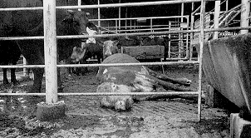
“downer” cow
Transport to the slaughterhouse has made
this cow too sick to stand.

Mad-cow disease could trigger trade war

The Washington Times
Wed, Aug 13 1997

A European frenzy over mad-cow disease is making its mark on everything from lipstick to pain relievers and now is threatening to provoke a trade spat with the United States.

In an attempt to prevent the spread of the contagious and still mysterious disease, the European Union last week said it would completely ban the use of certain animal parts such as skulls, eyes, brains, tonsils, spinal cords and spleens, which are thought to carry the malady.

Spleens and spinal cords don't sound very appealing, but after they're converted into a fatty substance called tallow they're used to make things such as eye shadow, lotion, pills and soap. The biotech industry uses tallow to make cell cultures. Printers use it in their ink.

And a European ban on all tallow would block a $100 million U.S. export, which in turn could drive cattle commodities into the ground.

"They're flipping out," said Chandler Keys, vice president of public policy for the National Cattlemen's Association. "Tell me how crazy the Europeans are about agriculture."

The European rules don't go into effect until January, but already the United States is gearing up for a fight at the World Trade Organization.

"Certainly it is WTO-illegal," U.S. Trade Representative Charlene Barshefsky said last week. "If the directive isn't changed, we will take Europe to the WTO."

Mad-cow disease, or bovine spongiform encephalopathy, caused a panic last year when the British government announced that a fatal human brain illness might be caused by eating infected beef. At least 10 Britons died of the disease.

No one has proved that the beef caused the disease, which hasn't been found in American cattle. British cows are thought to have gotten the illness from their feed, which includes parts from slaughtered sheep and other animals.

The U.S. livestock industry last year banned such parts in cattle feed.

The EU fears that mad-cow disease could be traveling through the food chain. A sheep with the disease is fed to the cow, which is rendered into tallow and used to make, say, a bar of soap, which is then used by a human.

Tallow is made from an animal's inedible parts, which are ground up and cooked into a liquid. That liquid, the tallow, is then further processed for use in dozens of products.

Eliminating what the Europeans call the "risk material" from the food chain would be akin to performing surgery on an animal before it's rendered, say opponents of the measure.
continued on next page

said Tom Cook, executive director of the National Renderers
Association.

The ban has thrown European industry into chaos, forcing many
companies to order tallow now for use next year.

Pharmaceutical makers say tallow is used in almost all pills and
powders. Gelatin, another product threatened by the ban, is used to
make the smooth coating on many pills.

But drug makers say taking an aspirin won't give anyone mad-cow
disease.

"We've done some estimates, and we'd say you're more likely, on
probably a few orders of magnitude of a billion, to be struck by
lightning," said Gillian Woollett, assistant vice president of biologics
and biotechnology at the Pharmaceutical Manufacturers Association.

But Europe traditionally has chosen to err on the side of caution. The
EU earlier this year lost a case at the WTO because it banned the use of
growth hormones in beef - in other words, a ban on almost all U.S. beef
exports.

Franz Fischler, the EU's commissioner for agriculture, said last week
that the ban was made on "precautionary grounds" and said economic
costs don't outweigh human health.

But the Cattlemen's Association's Mr. Keys sees another trade barrier
in disguise.

"We've got to fight the Europeans every step of the way on this stuff,"
he
said

Copyright 1997, The Washington Times.
When dining in restaurants, vegetarians often have it rough. Hidden animal ingredients abound. For example, Taco Bell's guacamole in its 7 Layer Burrito contains gelatin in the sour cream.

"I was bamboozled," laments Kevin Muhammad of Virginia Beach, Va., a vegetarian for religious reasons. Muhammad consumed Taco Bell's Veggie Fajita Wrap, not knowing it contains chicken and clam in the sauce.

Taco Bell supplies nutritional information quickly and accurately on its consumer line (1-800-TACO-BELL), whereas Wendy's hotline (1-800-82-WENDYS) makes getting it tough. Also chances of receiving correct information at the counter are slim, especially since Wendy's has recalled the fraudulent Nutrition Guides due to negative publicity stemming from false claims.

"They just don't want their customers to see what's in that guide -- it's like a smoking gun. By making the Nutrition Guide unavailable, they're making it even more difficult for customers to trust what's in Wendy's food," says Fish.

"Instead, Wendy's should have notified the public and recalled the gelatin-laced sauce back in May when vegetarians originally lodged complaints. Wendy's has alienated the very market they chose to court," says Fish. "Wendy's is showing a real lack of respect for the values of customers it is targeting," adds Weill.

Wendy's is apparently targeting the rapidly growing vegetarian market with its advertising. For example, a Veggie Pita commercial aired during "Paul McCartney's Town Hall Meeting" May 17 on VH-1. McCartney is a long-time vegetarian, and he asked everyone to "go veggie" during the program.

36 percent of all Americans look for a meatless entree when eating out, according to the May issue of Whole Foods. The National Restaurant Association is urging its members to add more vegetarian items to their menus because of growing demand.

The number of American adults claiming to be vegetarian showed a 100 percent growth rate over a six year period, according to a survey by Yankelovich Partners. The number adopting a vegetarian diet was one million adults per year -- about 20,000 per week.

"Dave could benefit by joining our ranks. He may be eating too much of his own stuff," says Weill. Thomas has heart disease and is recovering from a heart attack. A vegetarian diet has been shown to prevent -- and even reverse -- heart disease. American nonvegetarian men have ten times the heart disease death rate of total vegetarian men.
[Copyright 1997, Business Wire]

The average meat-eater is responsible for the killing of 1,500 warm-blooded animals in a lifetime, not counting pet foods.
news
"Everytime you turn around, the Europeans add something else {that's banned}. They add the skull, they add the spleen, they add the tonsils," said Tom Cook, executive director of the National Renderers Association.

The ban has thrown European industry into chaos, forcing many companies to order tallow now for use next year.

Pharmaceutical makers say tallow is used in many pills and powders. Gelatin, another product threatened by the ban, is used to make the smooth coating on many pills.

But drug makers say taking an aspirin won't give anyone mad-cow disease.

"We've done some estimates, and we'd say you're more likely, on probably a few orders of magnitude of a billion, to be struck by lightning," said Gillian Woollett, assistant vice president of biology and biotechnology at the Pharmaceutical Manufacturers Association.

But Europe traditionally has chosen to err on the side of caution. The EU earlier this year lost a case at the WTO because it banned the use of growth hormones in beef - in other words, a ban on almost all U.S. beef exports.

Franz Fischler, the EU's commissioner for agriculture, said last week that the ban was made on "precautionary grounds" and said economic costs don't outweigh human health.

But the Cattlemen's Association's Mr. Keys sees another trade barrier in disguise.

"We've got to fight the Europeans every step of the way on this stuff," he
said
Copyright 1997, The Washington Times.

Editor’s note- The WTO ruled the ban was illegal according to treaty.

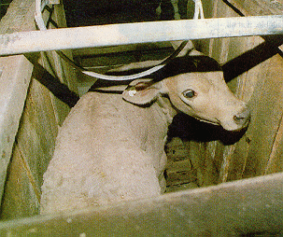
veal calf
in the crate where it will spend its short life.

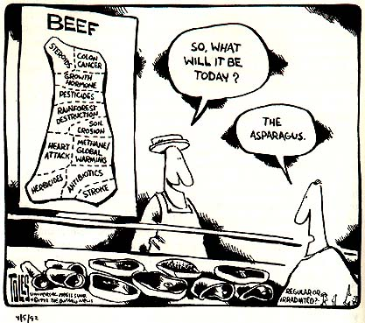
Action Alert!

Forwarded message:
From: maraya@BOULDERNEWS.INFI.NET (Maraya)
To: VEGAN@MAELSTROM.STJOHNS.EDU
Date: 97-07-26 04:42:05 EDT

ORIGINAL REPORT:
The Straits Times, June 30, 97. "EMUS KILLED: Penned in and unable to
escape, 22 emus were clubbed to death by a Texan frustrated by his financial losses in breeding the once-valuable flightless birds. The man and his brother were trying to relocate the emus to a rural property from a ranch in Colleyville near Fort Worth on Friday, but could not move the birds. They allegedly began beating them with an aluminum baseball bat. -- Reuter."

AND THEN:
United Poultry Concerns Action Alert
No Prosecution of Men Who Beat Twenty-Two Emus To Death?

July 23, 1997
Today in Tarrant County the District Attorney's Office announced it will not press cruelty charges against Steven and Russell Vinson, the two medical doctors who beat to death twenty-two penned emus with aluminum baseball bats on June 28, 1997.

The district attorney's office told UPC president Karen Davis on July 21 that there was no proof that the men's conduct was cruel. He said that maybe if the men had starved the birds or set them on fire the case might be different. The last bird to die in the pen was described by the humane investigator as "vomiting blood and staggering until it fell on the ground and couldn't get up anymore."

Attorney Richard Alpert, who recommended not to prosecute, told Karen Davis that breeders all over Texas are beating their emus to death "even as we speak." He said the only difference between the Vinsons and others is that the other breeders "generally tie the birds up first." He said this as if to say that the fact that others are beating their emus to death makes
it a common practice so it is not "cruel" or a crime under the law.

What Can I Do?

Contact:
Robert Mayfield
Deputy Chief, Misdemeanor Court
Tarrant County Criminal Justice Building
401 West Belknap
Fort Worth TX 76196
ph: 817-884-1649
fax: 817-884-2499

Tell him to revise the decision and to recommend prosecution of Steven and Russell Vinson, the two brothers who beat their captive emus to death. Their decision compounds the evil and sends a message to other breeders that they can beat their birds to death without fear of legal consequences.
___________________________________________________________
franklin@smart.net Franklin D. Wade
United Poultry Concerns - http://www.envirolink.org/arrs/upc
Compassion Over Killing - http://www.envirolink..org/arrs/cok
recipes


Living Graves

We are the living graves of murdered beasts,
Slaughtered to satisfy our appetites.
We never pause to wonder at our feasts,
If animals, like men, can possibly have rights.
We pray on Sundays that we may have light,
To guide our footsteps on the path we tread.
We're sick of war, we do not want to fight -
The thought of it now fills our hearts with dread,
And yet - we gorge ourselves upon the dead.

Like carrion crows we live and feed on meat,
Regardless of the suffering and the pain
we cause by doing so, if thus we treat
defenceless animals for sport or gain,
how can we hope in this world to attain,
the PEACE we say we are so anxious for.
We pray for it o'er hecatombs of slain,
to God, while outraging the moral law,
thus cruelty begets its offspring - WAR.

George Bernard Shaw (1856-1950)

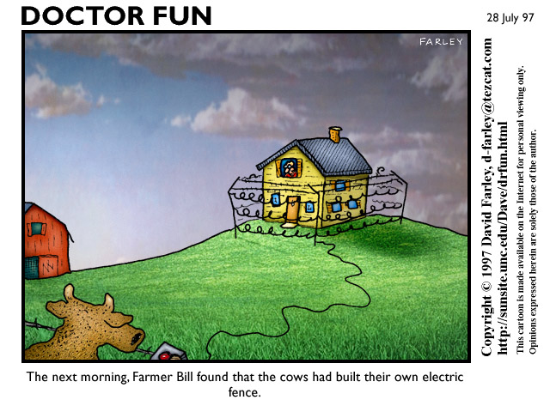

Textured Vegetable Protein and You

These two recipes have the advantages of being very very cheap, tasty, adaptable, and easy. The sloppy joe recipe is the one we used for fund raisers last semester. These recipes are very flexible. Feel free to change the ingredients to suit your taste. You can buy TVP in bulk at Cornucopia, the health food store across from H.E.B. in town. TVP is made from grains and looks very much like a bland form of grape nuts when it is dry.

TVP Sloppy Joes

2 small-medium green peppers
2 medium or 4 small onions
1 1/2 cup boiling water
2 1/2 cup tomato sauce
1 1/2 cup tvp
2 Tbsp. mustard (or more)
2 tsp. chili powder
1/2 tsp. salt
1 Tbsp. or so of soy sauce
1/2 tsp. pepper
1 tsp. sugar (I use Sucanat)

In a very large covered frying pan or pot, saute onions and
peppers in water. When mostly cooked, add remaining
ingredients and stir well. Cook on medium for 20
minutes, covered, stirring occasionally. When done,
serve on a burger bun or over toast, english muffins, or rice.

From SUSAN WYLDER ZF_WYLDER@scsu.edu:

Quick Barbeque Sandwiches

1 cup TVP
1/2 cup water
1 medium onion, chopped fine
1 or 2 cloves garlic, minced
water or other liquid for sauteing
your favorite barbeque sauce or mustard sauce

Mix the TVP with the 1/2 cup water and set aside for 5
minutes.

Saute onion in about 1 Tbs. liquid until almost clear.
Then add garlic and cook for another minute. Add the
reconstituted TVP. Add the barbeque sauce until the
mixture is the right consistency for sandwiches. Heat
thoroughly and serve.

internet

A quick reference guide to internet animal rights sites
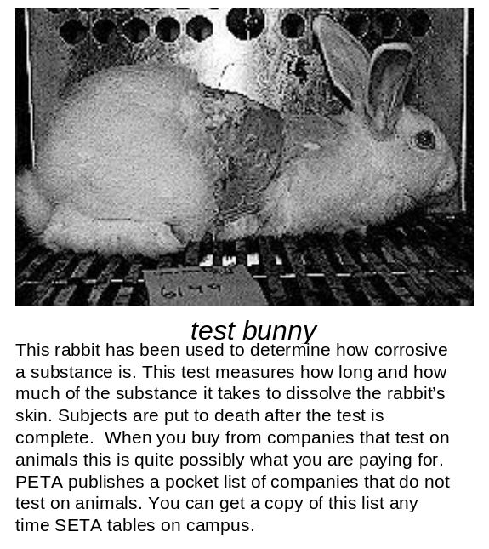
SETA web page http://www.swt.edu/studentorg/seta/index.htm
This page on the university web server offers SETA information with links to
animal rights philosophy, vegetarian sites, SETA’s at other campuses, and
more. Special section for those considering becoming vegetarian.

Vegweb http://www.vegweb.com
‘Your online guide to vegetarianism’. This site has a recipe directory with
over 2000 vegan recipes, a personals board, a chat area, and a informative
selection of files, discussion areas, and links. If you use this site you will
quite possibly never need to buy a cookbook ever again.

Envirolink http://www.envirolink.com
This site is not strictly limited to animal rights, but here you will find an
excellent selection of enviromentally and progresively minded information.

PETA http://www.peta-online.org/
People for Ethical Treatment of Animals. PETA maintains a complete set
of their fact sheets online as well as up to the minute action alerts. The
site is currently undergoing a major upgrade with more and more online
every day.

U. of Toronto SETA http://www.campuslife.utoronto.ca/groups/seta/
This is probably one of the more information rich sites from our friendly
northern SETA activists

Students for the Ethical Treatment of Animals
Southwest Texas State University
San Marcos, TX 78666

If you would like to be removed from our mailing list just tell us.



